JAVA ASSIGNMENT 4
Please find the example output for 2 files:
1.File name: SBC002.txt
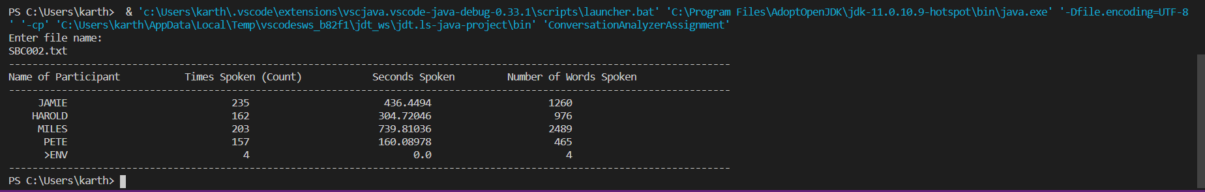

2.File name: SBC031.txt
